Content Area | World Languages |  |  | Proficiency Range Level | Novice Mid
Course Name/Course Code
Standard | Grade Level Expectations (GLE) |  |  |  |  |  | GLE Code
- Communication in Languages Other Than English | - Participate in basic conversations (written or oral) on a variety of familiar and predictable topics using isolated words and learned phrases (interpersonal mode) |  |  |  |  |  | WL09-NM-S.1-GLE.1
- Communication in Languages Other Than English | - Comprehend short learned exchanges (written or oral) on learned topics that use learned vocabulary and grammatical structures (interpretive mode) |  |  |  |  |  | WL09-NM-S.1-GLE.2
- Communication in Languages Other Than English | - Present using learned and simple phrases or expressions (written or oral) on very familiar topics (presentational mode) |  |  |  |  |  | WL09-NM-S.1-GLE.3
- Knowledge and Understanding of Other Cultures | - Reproduce common practices of the cultures studied |  |  |  |  |  | WL09-NM-S.2-GLE.1
- Knowledge and Understanding of Other Cultures | - Describe familiar products of the cultures studied |  |  |  |  |  | WL09-NM-S.2-GLE.2
- Connections with Other Disciplines and Information Acquisition | - Summarize information gathered from target language resources connected to other content areas |  |  |  |  |  | WL09-NM-S.3-GLE.1
 | - Organize information acquired from authentic resources |  |  |  |  |  | WL09-NM-S.3-GLE.2
- Comparisons to Develop Insight into the Nature of Language and Culture | - Expand knowledge of similarities and differences of basic structural patterns of language through comparisons of the student’s own language and the language studied |  |  |  |  |  | WL09-NM-S.4-GLE.1
 | - Investigate the nature of culture through comparisons of the target culture(s) and the student’s own culture and how the two cultures interact |  |  |  |  |  | WL09-NM-S.4-GLE.2
Colorado 21st Century Skills  Critical Thinking and Reasoning: Thinking Deeply, Thinking Differently  Information Literacy: Untangling the Web  Collaboration: Working Together, Learning Together  Self-Direction: Own Your Learning  Invention: Creating Solutions |  | 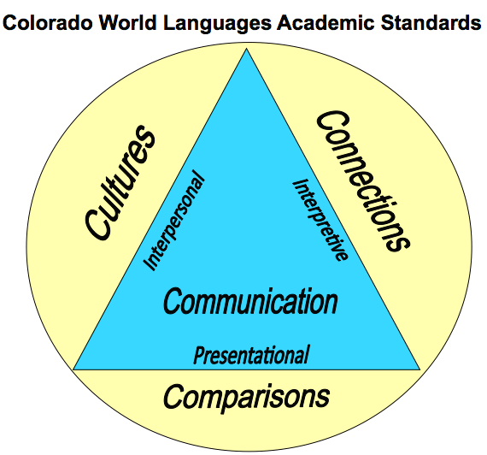  The Colorado World Languages Standards describe what learners should know and be able to do as they develop proficiency in a foreign language. Communication is at the center using the interpersonal, interpretive and presentational modes. Communication is then supported by understanding cultural perspectives, making connections to other disciplines and comparing one’s own language and culture with the new language.
Unit Titles |  |  | Length of Unit/Contact Hours |  |  | Unit Number/Sequence
Let’s Explore the City! |  |  | 3 Weeks = 15 Days = 15 Hours

Unit Title | Let’s Explore the City! |  | Length of Unit |  | 3 Weeks = 15 Days = 15 Hours
Focusing Lens(es) | Navigation | Standards and Grade Level Expectations Addressed in this Unit |  | WL09-NM-S.1-GLE.1; WL09-NM-S.1-GLE.2; WL09-NM-S.1-GLE.3;  WL09-NM-S.2-GLE.1; WL09-NM-S.2-GLE.2;  WL09-NM-S.3-GLE.1; WL09-NM-S.3-GLE.2;  WL09-NM-S.4-GLE.1; WL09-NM-S.4-GLE.2
Inquiry Questions (Engaging- Debatable): | - How does a person successfully navigate a city?
Unit Strands | 1. Communication in Languages Other Than English 2. Knowledge and Understanding of Other Cultures  3. Connections with Other Disciplines and Information Acquisition 4. Comparisons to Develop Insight into the Nature of Language and Culture
Foundational Concepts in World Languages | Interpersonal Communication, Interpretive Communication, Presentational Communication, Cultures, Connections, Comparisons
Concepts | Transportation, Travel, Directions, Navigate, Exploration

Generalizations  My students will Understand that… | Guiding Questions  Factual Conceptual
Successful navigation of a given city or urban environment requires the correct interpretation of a map from a target culture. | What does a city map in the target culture look like? | How does a person successfully interpret a city map?
The application of directions in a target language helps individuals to reach a destination in a city in the target culture. | What are the key words necessary to navigate a city in the target culture? | How are directions given differently in the target culture?
The use of target city’s transportation system can provide effective travel mean and an efficient way to visit important landmarks. | What are a city’s modes of transportation and its patterns of movement? | How do people negotiate modes of transportation and patterns of movement in order to explore a city effectively?

Critical Content:  My students will Know… |  | Key Skills:  My students will be able to (Do)…
Culture: | - City layout  - Paper and digital maps  - Social register | Within the context of this unit, students will be able to demonstrate in the target language the three modes of communication – interpersonal, interpretive and presentational. Some examples can include, but may not be limited to:  - Use maps to navigate throughout a city  - Ask for and give directions  - Identify places in the city and describe how to go there  - Identify modes of transportation and explain how to use them  (WL09-NM-S.1-GLE.1) and (WL09-NM-S.1-GLE.2) and (WL09-NM-S.1-GLE.3)
Context: | - Places and landmarks in the city  - Modes of transportation  - Directions
Structure: | - Verbs used to ask for/give directions  - Prepositions  - Commands  - Question formation
Connections to: | - Geography  - Social Studies  - Math

Critical Language: includes the Academic and Technical vocabulary, semantics, and discourse which are particular to and necessary for accessing a given discipline.
Academic Vocabulary: | Ask, answer, interpret, recognize, identify, explain, discuss, tell, express, reflect, share, describe
Technical Vocabulary: | interpersonal, interpretive, presentational, grammatical terms, practices, products, perspectives, connections, performance, proficiency range

