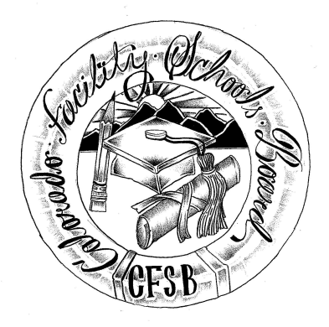
Colorado Facility Schools Board Meeting
Thursday, March 13, 2025
9:30 a.m. – 2:30 p.m.
In Person Venue: TACT- 2960 S Umatilla St, Englewood, CO 80110
Zoom Link

Time | Agenda Item | Participants
9:00am | Arrivals/ Tour
9:30am | Board Meeting (Co-Chair calls meeting to order)  Approval of Minutes Action Item  Approval of Agenda Action Item | Board
9:35am | Public Comment –Members of the public who wish to address the board must sign up 24 hours prior to the meeting using this link – Public Comment Sign-up Sheet. Presentations are limited to 3 minutes, with a maximum of 10 people. Additional guidance on public comment on the following page. If you plan to attend a meeting and need translation or accommodations, please notify Lori Kochevar, Kochevar_L@cde.state.co.us, at least 2 weeks prior to the meeting date. Advance notice allows CDE time to set up requested accommodations or translation services before the meeting. | Board/ Public
9:40am | Megan Coggins Confirmation of Board Seat | Judy Stirman/ Board
9:45am | Havern Autism Program, Authorize Day School. Presentation Requesting Facility School Approval  Action Item- Approval Vote | Robyn Ledebuhr  Board
10:30am | PRN for Families – Introduction to the board/ Virtual | David Molineux
10:40am | Break
10:50am | Elevation Ability -- update on specialized day school status | Wendy Dunaway
11:00am | Upcoming expiration of board members (Megan Coggins, Mylynda Herrick, Sonjia Hunt ) terms and board vote on whether to recommend reappointment of these members by the State Board of Education  Action Item- Recommendation Vote | Judy Stirman  Board
11:15am | Strategic Plan review of Mission, Vision, Values and Verification and look at Work Plan, update of the Facility School Board Committees or Projects Listing | Virginia Winter/ Board
11:35am | TACT Site Update | Lori McClurg/ Becky Mershon
12:00pm | Lunch/Tour (45min)
12:45pm | Feedback and Discussion on Accreditation – Review Updated report template/ CDE Definitions | Wendy Dunaway/ Judy Stirman/ Board
1:15pm | Declare next month’s Board Dialogue Topic | Board
1:20pm | Confirm Board member tasked with March Board Corner | Darren Serrato
1:25pm | CDE Team Updates | Facility Schools Staff
2:00pm | Adjournment of Meeting  Next Meeting Date – April 17, 2025.  In Person – Shiloh House Family Resource Pavilion Located at 9700 E Easter Ln, Centennial, CO 80112 | Board
2:30pm | Final Site Tour | Becky Mershon

Colorado Facility Schools Board Meeting
Thursday, March 13, 2025
9:30 a.m. – 2:30 p.m.

Additional information for those wishing to provide public comment –
This meeting will be open for members of the public for the entire meeting via the zoom link - https://us02web.zoom.us/j/82140573933?pwd=HY7MRjeSUalymUI0kvG46gXGL3znBr.1

Members of the public who wish to address the board must sign up 24 hours prior to the meeting using this link – Public Comment Sign-up Sheet. Presentations are limited to 3 minutes, with a maximum of 10 people. Additional guidance on public comment below.
Accommodation and Translation Notice:
If you plan to attend a meeting and need translation or accommodations, please notify Lori Kochevar, Kochevar_L@cde.state.co.us, at least 2 weeks prior to the meeting date. Advance notice allows CDE time to set up requested accommodations or translation services before the meeting.
If you have requested accommodations or translation services for a meeting and are then unable to attend, we ask for at least a 72-hour notice of cancellation, so that CDE can be proactive with cancelling requested accommodation services ahead of the meeting. Thank you!
Information regarding public comment:
DO:
§ Introduce yourself and where you are from. If you are speaking on behalf of an organization, identify the organization and your association.
DO: (Continued)
§ If speaking to a specific agenda item, limit your remarks to the subject of the agenda item and avoid repeating what others have said.
§ Be brief, to the point, and concise.
§ If you believe an issue needs to be explained in-depth, and you bring handouts, please pass them to staff prior to making your comments. Be sure to include your name and date of the meeting on the handout.
DO NOT:
§ Expect the board to answer any questions you may have.
§ Expect the board to be able to intervene with local school district issues. As Colorado is a local control state, district-specific issues should be resolved locally.
If you have questions about state law and local requirements, CDE staff may be able to assist you in finding an appropriate way to address your concerns.
§ Discuss personnel matters with the board. This should be done in private with the chair and/or vice-chair of the board.

